Request for Applications (RFA)
Downtown Sioux Falls, Creative Intersection Project
Issued: July 23, 2025
Issued by: Downtown Sioux Falls Neighborhood Association
Project Location: 11th Street & Phillips Avenue intersection
Proposal Submission Deadline: August 12, 2025, 11:59 PM CST
Proposal Submission Site: Submit Your Application Here
Contact: Kadyn Wittman | kadyn.wittman@gmail.com

1. Project Summary

The Downtown Sioux Falls Neighborhood Association (DTSFNA), in collaboration with local partners, invites artists and design professionals to submit applications to be considered for a new public art initiative, the Creative Intersection Project.

This project will transform downtown intersections into bold, colorful public artworks that celebrate the character of our community while enhancing pedestrian safety and visibility by improving driver and pedestrian awareness. Final artwork will be executed using thermoplastic material, a durable surface medium installed by a professional contractor.

The selected artist will be commissioned to develop a final design for the approved location, which includes 3 buffer zones at the 11th St & Phillips Ave intersection. All applications will be kept on-file for potential selection for additional intersections in future years.

2. Goals & Key Themes

The project aims to:
- Increase pedestrian and intersection visibility and safety
- Reflect the culture, joy, and energy of Downtown Sioux Falls
- Foster a sense of belonging and creativity through public space
- Uplift the visual identity of the neighborhood with inclusive, dynamic designs

Artists are encouraged to reflect one or more of the following themes:
- Sioux Falls community, culture, or history
- Joy, movement, and belonging
- Nature or prairie themes
- Bold, playful, and inclusive visuals

3. Technical, Site & Design Considerations

a. Installation Site: 11th St & Phillips Avenue
Dimensions provided below are approximate. The selected artist will be asked to coordinate with representatives of the City of Sioux Falls to field verify all measurements before finalizing designs.

The approved locations for graphic application are identified in the red shaded and outlined areas in the following photographs. Each area should match the width of the corresponding white transverse line, and should be approximately 4’ high.

Designs must not interfere with City white transverse lines and must begin just outside those lines (recommended artwork width: approx. 4’).

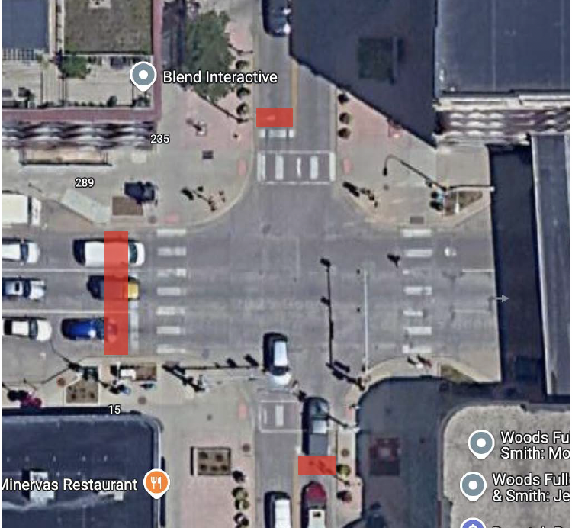
11th St & Phillips Avenue locations:
- 11th & Phillips, N = 9’4” x 4’
- 11th & Phillips, W = 31’6” x 4’
- 11th & Phillips, S = 9’6” x 4’

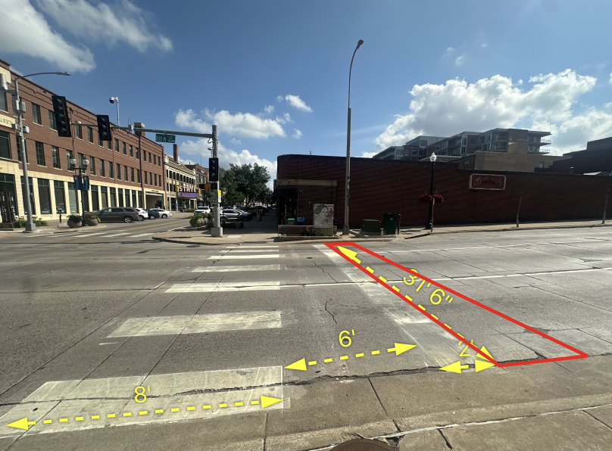
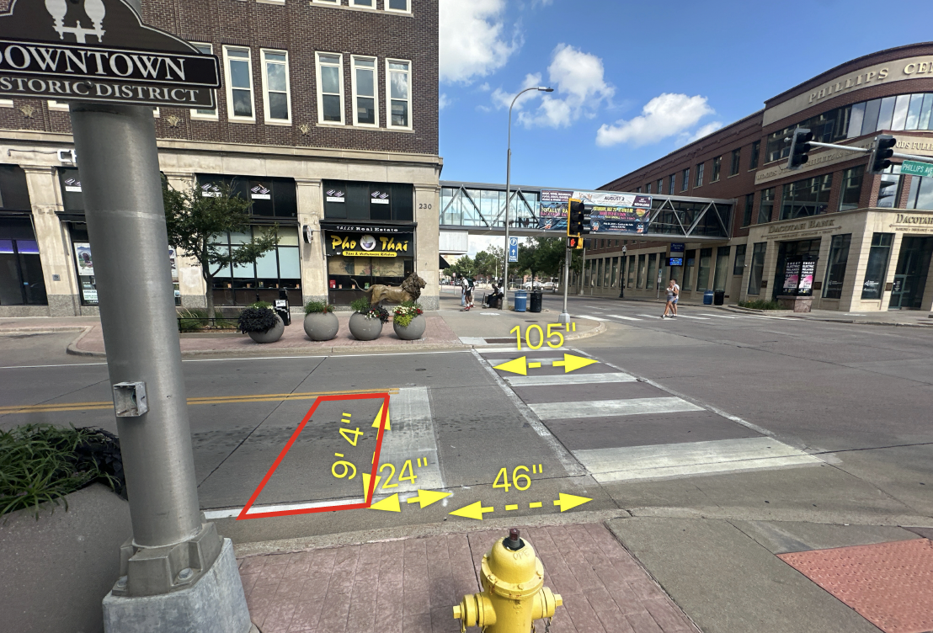
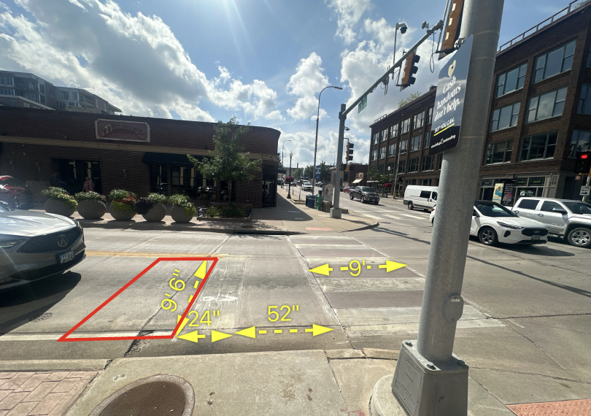
1) 11th & Phillips, N 2) 11th & Phillips, W 3) 11th & Phillips, S

b. Medium, Materials & Complexity:
Designs will be fabricated and installed using thermoplastic materials. Final artwork must adhere to technical constraints of this medium:
- Maximum of five (5) colors.
- Bold, graphic forms only—no fine detail, gradients, or thin lines
- No words, logos, or traffic-style symbols
- High visual contrast for ADA compliance
- Avoid resemblance to official signage or trademarked designs
- Must not interfere with crosswalk markings
- Must not include traditional traffic colors (red, yellow, green)
- Color palette options (with the exception of the colors noted above, include:)

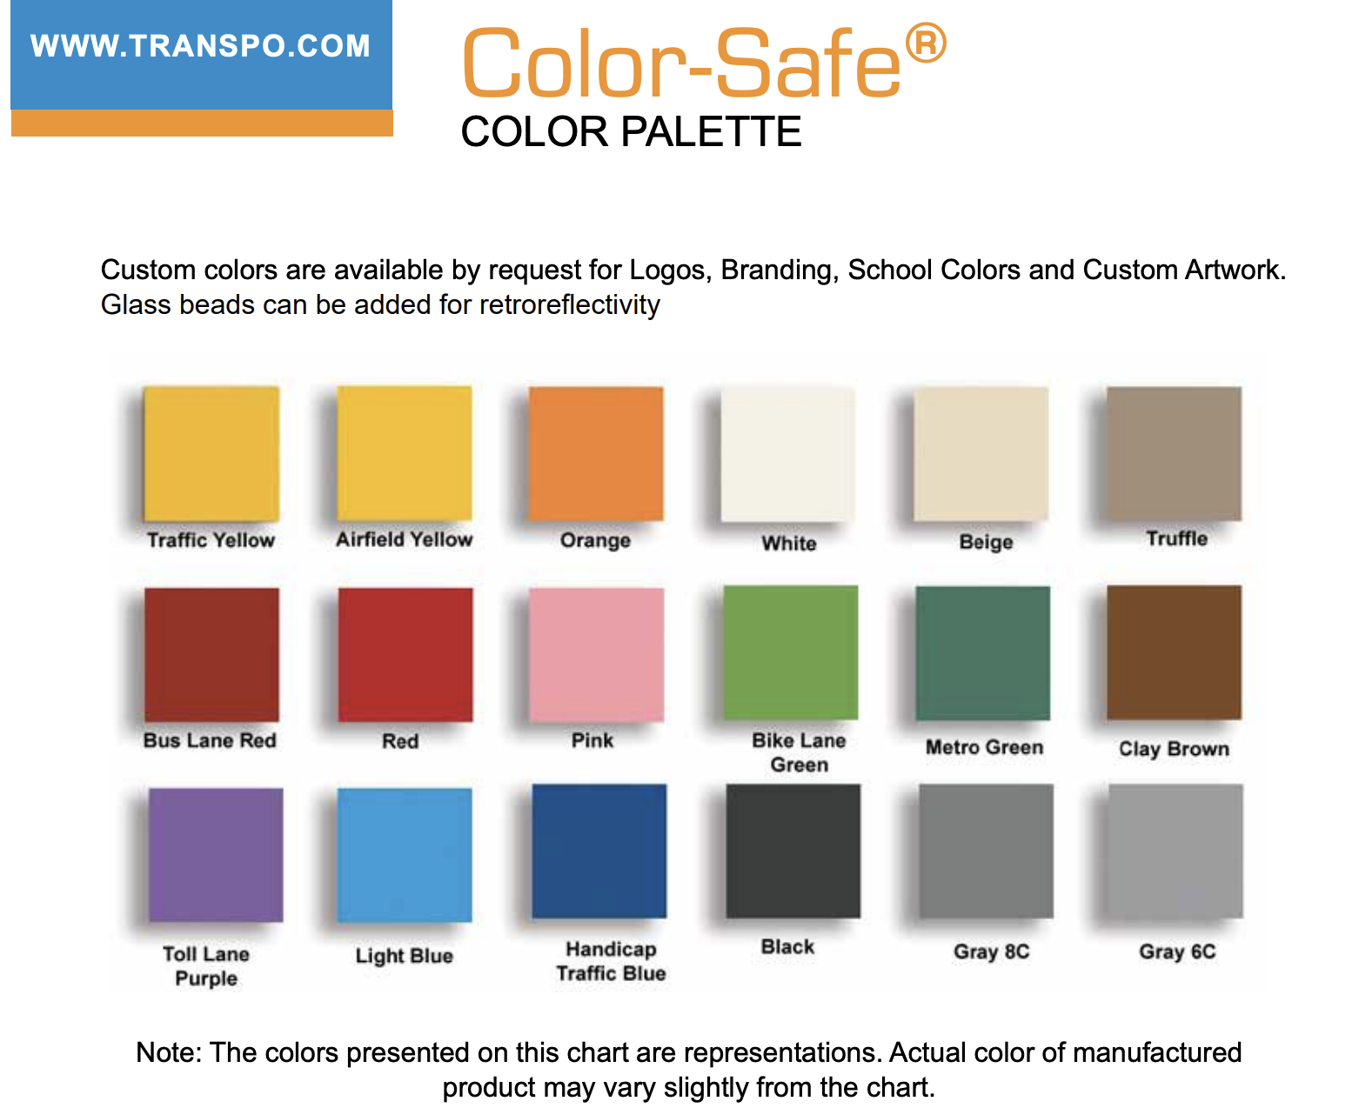

Reference images for inspiration and guidance on complexity and approximate scale:
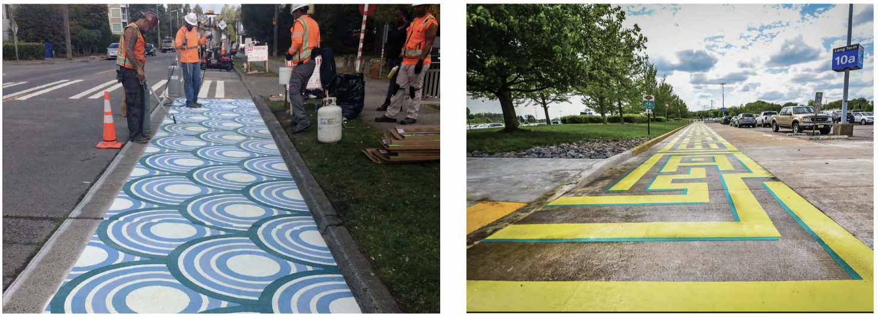

4. Budget
The selected artist will receive a design fee of $1,000 for the development of one final artwork.
This includes the creation of 2–3 preliminary concepts for review and one final, high-resolution design to be delivered as a digital file, scaled to fit the designated intersection areas.
Artists are not responsible for fabrication or installation. A professional vendor will handle all aspects of thermoplastic application in coordination with the City.
5. Project Timeline
- RFQ Release: July 23, 2025
- Submission Deadline: EOD August 12, 2025
- Selected Artist Notification: August 21, 2025
- Design Development & Final Design Submission: August 21-Sept 16, 2025
- City Approval Process (VAC/ATB): September 2025
- Installation Period: October 2025

6. Selection Process & Criteria

Submissions will be reviewed by a selection panel consisting of Downtown Residents Association board members, arts professionals, and City representatives. Artists will be evaluated based on:
- Quality and originality of past work
- Feasibility and clarity of artistic approach
- Alignment with project goals and themes
- Suitability for thermoplastic installation
- Preference may be given to local artists

7. Application Requirements
To apply, please complete and submit your materials using the following form by August 12, 2025, at 11:59 PM CST:
Submit Your Application Here
Required Materials (to be submitted through the form):
- Full name and contact information
- Brief artist bio (150 words max)
- Up to 3 sample designs or up to 3 images of past relevant projects or graphic designs (PDF, JPG, or PNG)
- A short project narrative (1–2 paragraphs) outlining your concept, approach, and any anticipated needs for execution
No application fee. Collaborative submissions welcome.

8. Questions & Accessibility

For questions or alternate format requests, contact:
Kadyn Wittman
Email: kadyn.wittman@gmail.com

Let’s bring color, creativity, and community spirit to our downtown intersections. We invite you to help reimagine the streetscape of Sioux Falls, one intersection at a time.

